DESTINY DISCOVER APP – FOR IOS AND ANDROID DEVICES
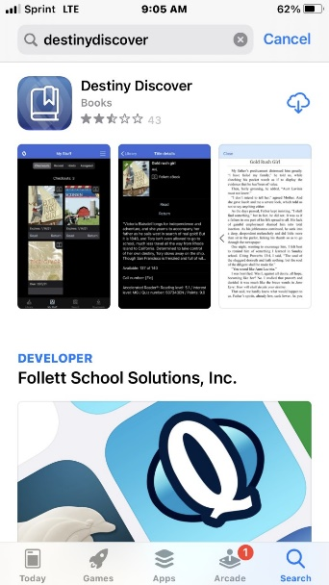
Read Freedom High School eBooks or listen to audio books online. Checkout the material so you have it available to read as needed. You can also download the files to use on your device without internet.
How to download and use the Follett Destiny App to access and use Freedom High School Digital resources:
1. Go to your device app store and type DestinyDiscover. Download the free app.
2. Open the DestinyDiscover app. Type in Freedom High School Woodbridge and select our school. Then select, “That’s my school.”
3. Select continue.
1
4. Login with PWCS login & password. Then Submit.
5. That’s it! You have access. When you search for materials if you don’t tell Destiny that you are looking for just eBooks it will show you everything print, audio and eBooks. To learn how to search for a certain type of material, eBook, print or audio book, continue reading.
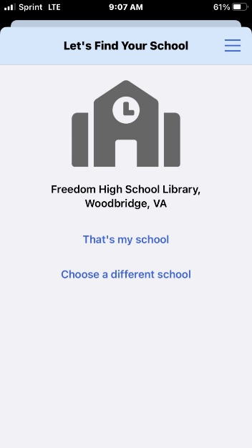
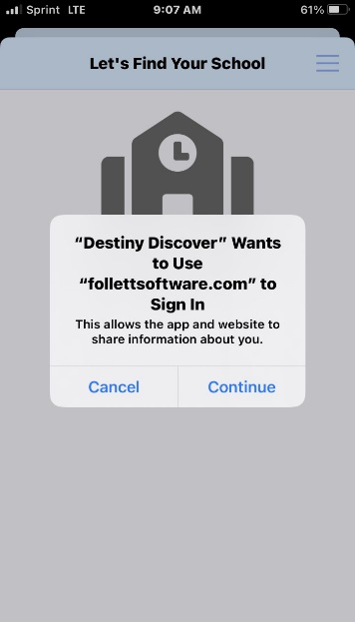
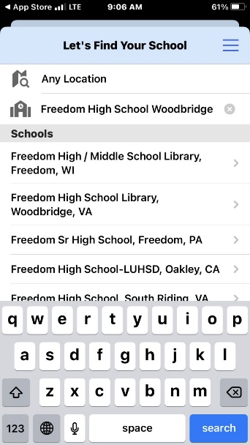
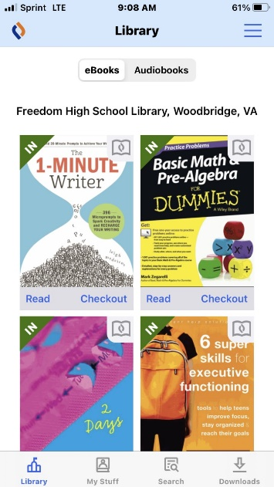
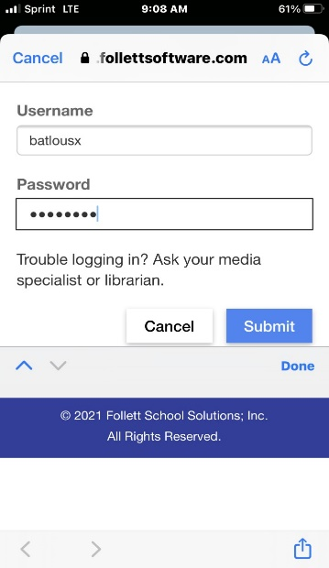
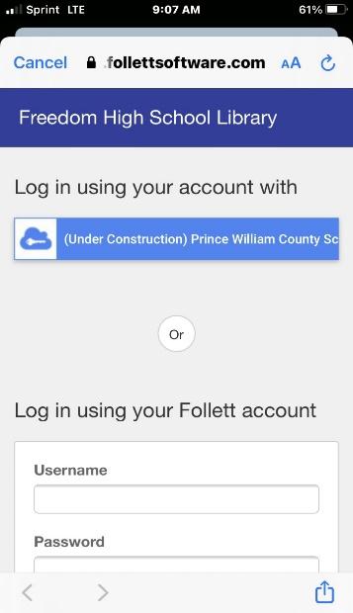
3
2
5
4
4
2
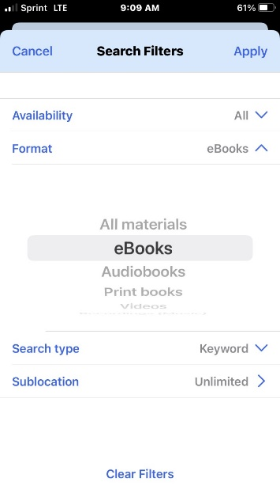
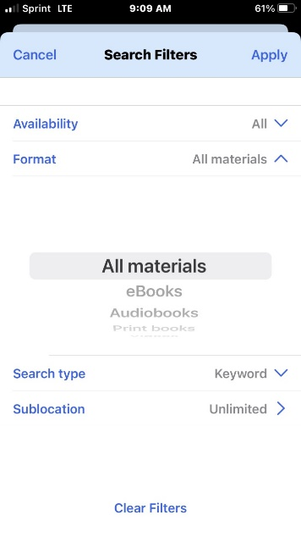
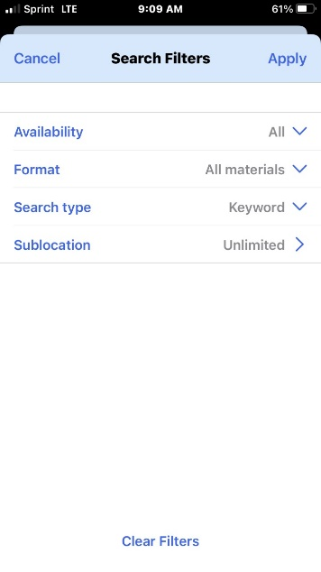
How to for specific materials within DestinyDiscover
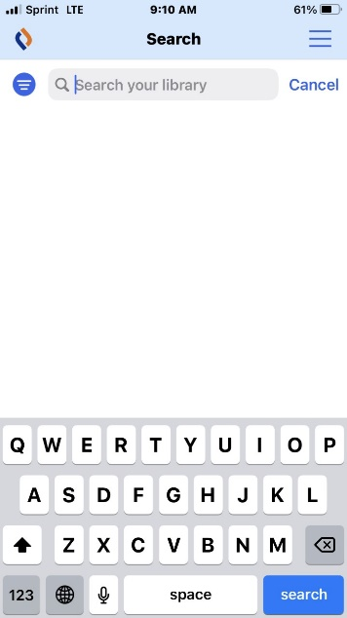
Since my filter was eBooks when I search, I will only get results that are eBooks.
Freedom High School has over 5,000 electronic resources for you to browse, checkout and read online. You can download the file to read without needing internet.
Notice now the circle is dark blue informing you that you have selected a filter.
In this case I chose eBooks.
Roll down to the type of material you want to use.
Tap All materials dropdown
Click on the little blue circle.

